Introduction to Digital Marketing
Today’s time of Internet has opened the gateway of tremendous digital marketing opportunities for businesses. By utilizing different channels of digital marketing, businesses cannot just share their product and services online; additionally they can gain clients for their business, entice them and can convert them to boost their ROI. The speed and straightforwardness with which the digital media transmits data and support a business is astonishing. In this Introduction to Digital Marketing E-Guide, every single aspect of Digital Marketing will be discussed to help marketers understand what Digital Marketing is, how it functions, and how it can help them optimize their marketing campaign.
The world is super-connected nowadays and all things considered, marketing and advertising are no more the same as they once were. This is particularly valid because of the ascent of online networking, which has changed how organizations speak with potential and existing customers.
So, before jump onto the introduction to Digital Marketing, let’s know what precisely Digital Marketing is and what does it incorporate? Essentially, it is an aggregate term, which is utilized where advertising and marketing meet web innovation and different types of online media platforms. Let’s firstly throw some light on the basics of Digital Marketing via the definition given below, this is the first step when we talk about the introduction to Digital Marketing-

Digital Marketing| Definition
Digital Marketing can be understood as a well-targeted, conversion-oriented, quantifiable, and interactive marketing of products or services by utilizing digital innovation to achieve the customers, and transform them into clients in a sustainable fashion. The whole concept and functionalities of Digital Marketing are more competent, effective, result-oriented and measurable, which make it very different from traditional marketing.
The traditional way of marketing lets businesses market their products or administrations on print media, radio and TV commercials, bill boards, business cards, and in numerous other comparable ways where Internet or web-based social networking sites were not utilized for promoting.
However, traditional promoting approaches had constrained client reachability and extent of driving clients’ purchasing conduct. In addition, traditional marketing methods were not quantifiable too. Let us understand noticeable difference between Traditional Marketing & Digital Marketing-

Difference b/w Traditional Marketing & Digital Marketing

Traditional Marketing
- Communication is unidirectional in traditional marketing, which means, an organization communicates about its services with its audiences.
- Medium of communication in traditional marketing is generally phone calls, emails, and letters.
- Campaign in Traditional marketing takes more time as designing, preparing, and launching are involved.
- It is best for reaching local audience.
- It is almost impossible to measure the effectiveness of a traditional marketing campaign.

Digital Marketing
- Communication is bidirectional in Digital Marketing as businesses can communicate with customers and customers can ask queries or make suggestions to businesses as well.
- Medium of communication is more powerful and involves social media websites, chats, apps and Email.
- Digital marketing campaigns can be developed quite rapidly and with digital tools, channelizing Digital Marketing campaigns is easier.
- It is very effective for reaching global audiences.
- Digital Marketing lets you measure the effectiveness of a digital marketing campaign through analytics.
Digital Marketing accomplishes targets of marketing of a business through various Digital Marketing Channels.

Evolution of Digital Marketing Era
The Growth of Digital Marketing has been rapid in the past few years. A decade ago, information from a handful of websites was enough for people to make a decision on an item. Today, no decision can be made before referring to multiple websites and digital media. Therefore, The Evolution of Digital Marketing Era looks bright.
The concept of digital marketing started with the advent of the internet and has evolved along with innovations in the internet and technology. The development of search engines like Google at the end of the 1990s and early 2000s, the emergence of social media websites, and the infringement of smartphones in our daily lives have all revolutionized the scope of digital marketing. Let’s see how the Evolution of Digital Marketing Era will become the future of marketing.

Mobile Marketing
Mobile phones have become more popular than any other digital device. 70% of browsing on the internet is now done with smartphones. The biggest advantage of smartphones is they are portable. Because they can be carried at all times, mobile advertising has become portable, too, and can follow individuals wherever they go.
Social Media Marketing Companies have begun to strategize methods to promote brands through mobile phones. Digital ads and SEO’s are now being optimized for the mobile medium. This ease of accessibility can be tapped through interactive marketing strategies by which users may get all the information they need on products through a single tap.

Online Marketing
People spend a large part of their time online and this online presence offers a great target audience for Digital marketing services are limited not just to e-commerce apps and website but they expand to social media platforms like Facebook, Twitter, Instagram, and so on. It is possible to connect to audiences all around the world and from all demographics.

Bitcoin Payments
Bitcoin was introduced in 2009, but it really took off by the end of 2017. The year 2018 is being touted by many experts as one in which cryptocurrencies and blockchain technology will really soar. Bitcoin is a pioneer in digital currency and it has gotten many companies excited. As it will allow buyers to make online transactions.

Influencer Marketing
Digital marketers are always looking for ways to collect more customers. One of the ways to do so is by advertising themselves on affiliate sites. This is known as influencer or Affiliate Marketing. For every lead that is brought from an affiliate site, a commission is paid to the owners of the affiliate website. Thus, one website promotes or advertises the products or services of another website. This helps marketers to acquire a greater reach and user traffic.

Social Media Marketing
Social media is one of the best ROI strategies available today as 3.77 billion people around the world use the internet, of which 2.8 billion use the social media. Due to its sheer size, social media can provide a huge amount of outreach and exposure for marketing.
A business must know how to take advantage of this data generated by users in real time. Every day people share a lot of information about themselves through their social media activities, through their tweets, photos, and posts, which offer valuable insights about the consumer, their preferences, likes and dislikes. All this information available on social media websites can help in Facilitating Marketing outreach.Thus, rising trends in digital technology provide boundless scope for various brands and industries to connect with their target audience. By focusing on building consumer experiences and making connections with them through digital means, a business and/or brand can have a fairly good chance to attain a competitive advantage.

Google Adwords
AdWords (Google AdWords) is an advertising service by Google for businesses wanting to display ads on Google and its advertising network. The AdWords program enables businesses to set a budget for advertising and only pay when people click the ads. The ad service is largely focused on keywords.
Businesses that use AdWords can create relevant ads using keywords that people who search the Web using the Google search engine would use. The keyword, when searched for triggers your ad to be shown. AdWords at the top ads that appear under the heading "Sponsored Links" found on the right-hand side or above Google search results. If your AdWords ad is clicked on, Google search users are then directed to your website.
When choosing keywords for your AdWords campaigns different matching options are available. The two main keyword match options include the following:
- Broad Match: This reaches the most users by showing your ad whenever your keyword is searched for.
- Negative Match: This option prevents your ad from showing when a word or phrase you specify is searched for.
- Phrase Match: Your ad is shown for searches that match the exact phrase.
- Exact Match: Your ad is shown for searches that match the exact phrase exclusively.
When using AdWords keywords are also used to determine your cost of advertising. Each keyword you choose will have a cost per click (CPC) bid amount. The bids specify the maximum amount you're willing to pay each time someone clicks your ad (the maximum cost-per-click). A higher CPC bid can allow your ad to show at a higher position on the page.

Definition - What does Search Engine mean?
Search engine is a service that allows Internet users to search for content via the World Wide Web (WWW). A user enters keywords or key phrases into a search engine and receives a list of Web content results in the form of websites, images, videos or other online data. The list of content returned via a search engine to a user is known as a search engine results page (SERP).

What is a Search Engine?
The purpose of a search engine is to extract requested information from the huge database of resources available on the internet. Search engines become an important day to day tool for finding the required information without knowing where exactly it is stored. There are different types of search engines to get the information you are looking for. Internet usage has been tremendously increased in recent days with the easy to use search engines like Google, Bing and Yahoo!

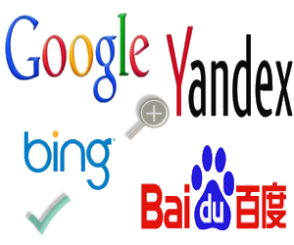

Different Types of Search Engines
Search engines are classified into the following three categories based on how it works.
- Crawler based search engines
- Human powered directories
- Hybrid search engines
- Other special search engines
Let us discuss all types of search engines in detail in the following sections.

1. Crawler Based Search Engines
All crawler based search engines use a crawler or bot or spider for crawling and indexing new content to the search database. There are four basic steps, every crawler based search engines follow before displaying any sites in the search results.
- Crawling
- Indexing
- Calculating Relevancy
- Retrieving the Result

1.1. Crawling
Search engines crawl the whole web to fetch the web pages available. A piece of software called crawler or bot or spider, performs the crawling of the entire web. The crawling frequency depends on the search engine and it may take few days between crawls. This is the reason sometimes you can see your old or deleted page content is showing in the search results. The search results will show the new updated content, once the search engines crawl your site again.

1.2. Indexing
Indexing is next step after crawling which is a process of identifying the words and expressions that best describe the page. The identified words are referred as keywords and the page is assigned to the identified keywords. Sometimes when the crawler does not understand the meaning of your page, your site may rank lower on the search results. Here you need to optimize your pages for search engine crawlers to make sure the content is easily understandable. Once the crawlers pickup correct keywords your page will be assigned to those keywords and rank high on search results.

1.3. Calculating Relevancy
Search engine compares the search string in the search request with the indexed pages from the database. Since it is likely that more than one page contains the search string, search engine starts calculating the relevancy of each of the pages in its index with the search string.
There are various algorithms to calculate relevancy. Each of these algorithms has different relative weights for common factors like keyword density, links, or meta tags. That is why different search engines give different search results pages for the same search string. It is a known fact that all major search engines periodically change their algorithms. If you want to keep your site at the top, you also need to adapt your pages to the latest changes. This is one reason to devote permanent efforts to SEO, if you like to be at the top.

1.4. Retrieving Results
The last step in search engines’ activity is retrieving the results. Basically, it is simply displaying them in the browser in an order. Search engines sort the endless pages of search results in the order of most relevant to the least relevant sites.

Examples of Crawler Based Search Engines
Most of the popular search engines are crawler based search engines and use the above technology to display search results. Example of crawler based search engines:
- Google
- Bing
- Yahoo!
- Baidu
- Yandex
Besides these popular search engines there are many other crawler based search engines available like DuckDuckGo, AOL and Ask.

2. Human Powered Directories
Human powered directories also referred as open directory system depends on human based activities for listings. Below is how the indexing in human powered directories work:
- Site owner submits a short description of the site to the directory along with category it is to be listed.
- Submitted site is then manually reviewed and added in the appropriate category or rejected for listing.
- Keywords entered in a search box will be matched with the description of the sites. This means the changes made to the content of a web pages are not taken into consideration as it is only the description that matters.
- A good site with good content is more likely to be reviewed for free compared to a site with poor content.
Yahoo! Directory and DMOZ were perfect examples of human powered directories. Unfortunately, automated search engines like Google, wiped out all those human powered directory style search engines out of the web.

3. Hybrid Search Engines
Hybrid Search Engines use both crawler based and manual indexing for listing the sites in search results. Most of the crawler based search engines like Google basically uses crawlers as a primary mechanism and human powered directories as secondary mechanism. For example, Google may take the description of a webpage from human powered directories and show in the search results. As human powered directories are disappearing, hybrid types are becoming more and more crawler based search engines.
But still there are manual filtering of search result happens to remove the copied and spammy sites. When a site is being identified for spammy activities, the website owner needs to take corrective action and resubmit the site to search engines. The experts do manual review of the submitted site before including it again in the search results. In this manner though the crawlers control the processes, the control is manual to monitor and show the search results naturally.

4. Other Types of Search Engines
Besides the above three major types, search engines can be classified into many other categories depending upon the usage. Below are some of the examples:
- Search engines have different types of bots for exclusively displaying images, videos, news, products and local listings. For example, Google News page can be used to search only news from different newspapers.
- Some of the search engines like Dogpile collects meta information of the pages from other search engines and directories to display in the search results. This type of search engines are called metasearch engines.
- Semantic search engines like Swoogle provide accurate search results on specific area by understanding the contextual meaning of the search queries.

Wrapping Up
During earlier days of Internet, human powered search engines were popular and important source of information. The technological world is moving very fast towards automation and artificial intelligence. Big technology companies like Google and Microsoft, who own the popular search engines, are driving this change and getting benefit out of it. None of the human powered search engines could survive this fast shift. Though people uses special purpose search engines in very small scale, at this point of time artificial or crawler based search engines acts as a primary source of information with minimal human interventio

Definition - What does Search Engine Optimization (SEO)mean?
Search engine optimization (SEO) refers to methods used to increase traffic to a website by increasing its search engine page rank.
SEO often involves improving the quality of the content, ensuring that it is rich in relevant keywords and organizing it by using subheads, bullet points, and bold and italic characters. SEO also ensures that the site’s HTML is optimized such that a search engine can determine what is on the page and display it as a search result in relevant searches. These standards involve the use of metadata, including the title tag and meta description. Cross linking within the website is also important.
Home / SEO Articles / Top 10 Search Engines In The World
by ALEX CHRISLEAVE A COMMENT

Top 10 Search Engines In The World
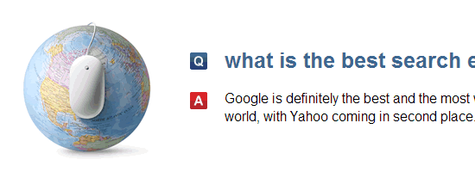
Which are the 10 best and most popular search engines in the World? Besides Google and Bing there are other search engines that may not be so well known but still serve millions of search queries per day.
It may be a shocking surprise for many people but Google is not the only search engine available on the Internet today! In fact, there are a number of search engines that want to take Google’s throne but none of them is ready (yet) to even pose a threat.
Nevertheless, there are search engines that are worth considering and the top 10 are presented below after the break.

List of Top 10 Most Popular Search Engines In the World (Updated 2018)

1. Google
No need for further introductions. The search engine giant holds the first place in search with a stunning difference of 66% from second in place Bing.
According to the latest netmarketshare report (January 2018) 74.52% of searches were powered by Google and only 7.98% by Bing.
Google is also dominating the mobile/tablet search engine market share with 93%!
Want to learn how to take advantage of Google’s search engine share? Read: How long does it take to rank in Google
2. Bing
Bing is Microsoft’s attempt to challenge Google in the area of search, but despite their efforts they still did not manage to convince users that their search engine can produce better results than Google.
3. Yahoo
Since October 2011 Yahoo search is powered by Bing. Yahoo is still the most popular email provider and according to reports holds the fourth place in search.
4. Ask.com
Formerly known as Ask Jeeves, Ask.com receives approximately 0.05% of the search share. ASK is based on a question/answer format where most questions are answered by other users or are in the form of polls.
It also has the general search functionality but the results returned lack quality compared to Google or even Bing and Yahoo.
5. AOL.com
According to netmarketshare the old time famous AOL is still in the top 10 search engines with a market share that is close to 0.04%. The AOL network includes many popular web sites like engadget.com, techchrunch.com and the huffingtonpost.com.
6. Baidu
Baidu was founded in 2000 and it is the most popular search engine in China. It’s market share is increasing steadily and according to Wikipedia, Baidu is serving billion of search queries per month. It is currently ranked at position 4, in the Alexa Rankings.

7. Wolframalpha
Wolframalpha is different that all the other search engines. They market it as a Computational Knowledge Engine which can give you facts and data for a number of topics. It can do all sorts of calculations, for example if you enter “mortgage 2000” as input it will calculate your loan amount, interest paid etc. based on a number of assumptions.
8. DuckDuckGo
Has a number of advantages over the other search engines. It has a clean interface, it does not track users, it is not fully loaded with ads and has a number of very nice features (only one page of results, you can search directly other web sites etc).
I am sure that some of the features of duckduckgo will be used by other search engines and with some proper funding duckduckgo can get a decent search engine market share.
9. Internet Archive
archive.org is the internet archive search engine. You can use it to find out how a web site looked since 1996. It is very useful tool if you want to trace the history of a domain and examine how it has changed over the years.
10. Yandex.ru
According to Alexa, Yandex.ru is among the 30 most popular websites on the Internet with a ranking position of 4 in Russian.
Yandex present themselves as a technology company that builds intelligent products and services powered by machine learning. According to Wikipedia, Yandex operates the largest search engine in Russia with about 65% market share in that country.
As a final word, if you search “What is the best search engine?” in any of the search engines listed above, you will get an answer that Google is the best and most popular search engine and Bing is in the second place (on a Global level).
These are the 10 best and most popular search engines on the Internet today.
The list is by no means complete and for sure many more will be created in the future but as far as the first places are concerned, Google and Bing will hold the lead positions for years to come.

Types of Search Engine Optimization (SEO)
June 17, 2014
Search Engine Optimization services have different types and if you have an online business, you need search engine optimization services for search engine ranking optimization of your website. Then you need to know the different types of SEO and how to use them. Remember, one of the most important key to being a smart client makes an informed decision. Three SEO types are black hat, white hat and gray hat. Techie Group Inc. is a Web Development company that can best help your online business.
Black Hat SEO is a type of SEO services that try to trick the search engine and manipulate the ranking of the site. These are often are not complying with the rules of the search engines. It uses keywords not related to have more traffic to the website and others spam to get more popularity of the site. An advantage of this method is that you can easily get at the top of the search engines, but can be risky, because if they discovered the spam, the site will be banned from the list. This also disappoints visitors due to lack of relevance of the keyword they are looking for in the search engines.
White Hat SEO is the opposite of black hat, since it is based on the quality of content and using keywords that are relevant to achieving the first rank in search engines. This is known as an effective marketing method to bring people to the site. However, the results can be visible after some time in this method, unlike the black hat. It may take some time before we see great results, but what is said to be the best strategy to boost web SEO search engine. Visitors will be delighted with the quality that makes this technique.
Grey Hat SEO is the combination of both black and white and may use questionable methods, following the guidelines of search engines. This can produce quick results as the black hat method, but is also risky.

SEO Life Cycle
In these days, a buyer goes online and pulls information by entering a query into a search engine. In return, search engine produces millions of results. Interestingly, after that more than 60% web traffic goes to the websites that are produced by the search engine on 1st SERP (Search Engine Result Pages). This whole science of ranking any website on top SERPs is actually SEO. Hundreds of books are available on SEO, so to cover this evolving topic in this short article will be an injustice. But, I can introduce you here with the “SEO Life Cycle” that will help you a lot with many queries of yours.
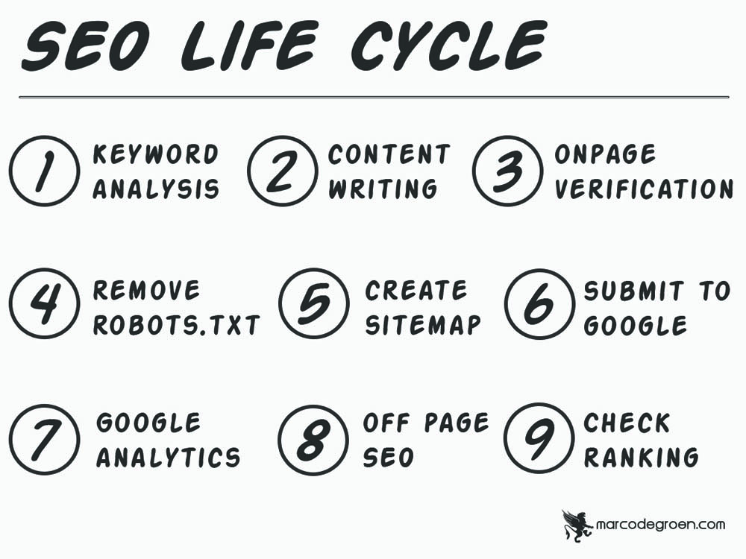
As promised I’ll try my best to introduce you to each stage of this cycle briefly. Let’s
start this journey.
Keyword Analysis:
If ranking on the top of a search engine is like a ripe fruit then the keyword is
the seed of that fruit. Every visitor enters a query in the search tab of a search engine and to find that query is your keyword analysis. Don’t worry several tools are available to run that analysis for you and the most famous one is “Google Keyword Planner”.
Content:
Content is the king and it has its importance in all the stages of a buyer’s journey from a visitor to its conversion as a customer. One of the main functions of any search engine is crawling. In case of Google, it is known as the crawler. That crawler actually scans each and every bit of the content
available on all the web pages of any website and gives its ranking to any content on the basis of relevancy and quality. Remember, content is not just the text, it can also be a video, image, info-graphics, and audio.

On Page SEO
Verification:
This stage of a life cycle has many factors, most important of them are mentioned here. You have to just read it and at this level don’t try to dig deep. Meta Title, Meta Description, Meta Key Words, Headings, Content of Page, Internal Linking, Content Formatting, Image Size, Image Naming
Convention, Image Alt-Tag, Videos, naming, Text to Code Ratio, Pop-Ups, Ads Management, Bounce Rate, Page Load Speed, CTR.
Robot.txt:
The crawler of Google also known as “bot”, derived from a robot. At this stage, you as an owner of your website will stop the search engine to crawl your page. The reason is simple as it is an early stage to expose your website to the competitive world.
Create Site Map:
At this stage, you have to create a whole sitemap of your website. It includes all the pages from “About Us” to your “Services”, “Resources”, “Blog”, “Contact Us” or any other.

Submit to web
Master (say Google):
This is the online master or regulator of your website, say Google webmaster. In simple word register your website with Google and let the “bot” now crawl your website.
Google Analytic:
I am writing Google again and again for ease of understanding and also due to the fact that it has more than 80% search share worldwide. Now, you start to analyze the performance of your efforts by many tools available at Google analytics platform. For example, the most important
factors can be traffic coming to your website, how many of them are actually engaged with the content of your website, how many of them submit their information, and much interesting information like these.
Off Page SEO:
It is also known as backlinking, means how many other authoritative websites are endorsing your web link. It tells the search engines about your page authority and domain authority, and higher is better.
Ranking:
Finally, it’s time to check whether the fruit that your seed produced has riped or not. Simply, you will check here the ranking of your site on the SERP. If you are ranking on the 1st SERP then you will mainly focus on your off-page SEO efforts and ranking, periodically. But, if you are not ranking among topper then revert back to your keyword analysis and content stages.

Organic Vs Inorganic
Organic & Inorganic SEO
Organic SEO
It is a natural way of getting top ranking in SERP (search engine result page) without paying any amount to search engines for the placement. This is more preferable and trustworthy method of securing high rank on SERP.
Benefits of Organic Search Engine Optimization:
Usually normal user’s clicks more on organically optimized sites.
Results are long lasting on search engine result pages.
Organic results are more trustworthy than inorganic results.
Organic service is cheaper than inorganic services.
Ways to Get Organic/Natural Results:
Analyze keywords, Content optimization, Site promotion, Meta content optimization, Image optimization, URL optimization.
Many SEO Experts says, organic SEO is the best way to follow. Many of you are following the same techniques to optimize site but might not aware that it’s organic SEO.
Inorganic SEO
It includes usually paid services such as PPC – Pay Per Click, CPC – Cost Per Click, CPA – Cost Per Acquisition, banner ads, classifieds etc. This service is very expensive. But those who wants immediate results, they can go for inorganic service.
Benefits of Inorganic Search Engine Optimization:
Results in short period. Site gains more visibility. More traffic in sort time period.Unlike organic SEO, inorganic SEO gets more effective result in very short time.
Inorganic SEO technique is quite risky; as its cost will be count as per clicks, webmaster must remain alert from competitors, they might click on your site unnecessarily to force you pay more. There is a solution to block those users, but for that you must be aware that they clicked you unnecessarily.
If you don’t have enough money to spend, it’s better to follow organic SEO technique which is far better than inorganic SEO.

